Nuclear Power Station

The nuclear power generating stations are similar to the thermal Power stations in more ways than one. However, the exception here is that, radioactive elements like Uranium and thorium are used as the primary fuel in place of coal. Also in a Nuclear Station the furnace and the boiler are replaced by the nuclear reactor and the heat exchanger tubes.

For the process of nuclear power generation, the radioactive fuels (Uranium-235, Plutonium-241) are made to undergo fission reaction within the nuclear reactors. The fission reaction propagates like a controlled chain reaction and is accompanied by unprecedented amount of energy produced*,(1kg of uranium-235 contains 7.2x1013//kg, of heat, where as heat released per* *kg of coal is 2.1x107J/kg)* which is manifested in the form of heat. This heat is then transferred to the water present in the heat exchanger tubes. As a result, super heated steam at very high temperature is produced.

Once the process of steam formation is accomplished, the remaining process is exactly similar to a thermal power plant, as this steam will further drive the turbine blades to generate electricity.

**COOLENT:** The heat generated in the reactor is is absorbed by the coolant to generate the steam.

Water, gas or liquid metal can be used ac coolant and are circulated through the reactor core to absorb the heat generated by the nuclear reaction .the properties of a good coolant are a) chemically stable ,b) corrosion resistant and c) should not absorb neutrons.

**CONTROL RODS:** The energy produced in the reactor is controlled by limiting the number of neutrons available for the nuclear fission. Pushing the controlled rod deeper in to the reactor absorbs more neutrons, but doing this reduces the power output, otherwise the control rods increases the output.

**MODERATORS**: Are used to slow down fast moving neutrons (13200m/s to220m/s) to make them suitable for nuclear fission. The moderators should be chemically stable, good corrosion resistant with high melting point. The neutrons should not be absorbed by the moderator. Some times the coolant and moderators are of the same material. The effectiveness of the moderator increases with the increase in density and decreases with decrease in density, since there is a variation in the temperature and pressure, the density of the coolant varies,

**Types of Nuclear Reactor:**

**Boiling Water Reactor (BWR)** In this type of reactor the coolant and moderator are same as De mineralized water. The DM water is converted in to steam by absorbing heat in the reactor core. The produced is sent to the turbine and exhaust steam is condensed in the condenser. The condensed water is pumped to the reactor. The pressure maintained is of the order of 75Bar so that the water boils at 2850C.

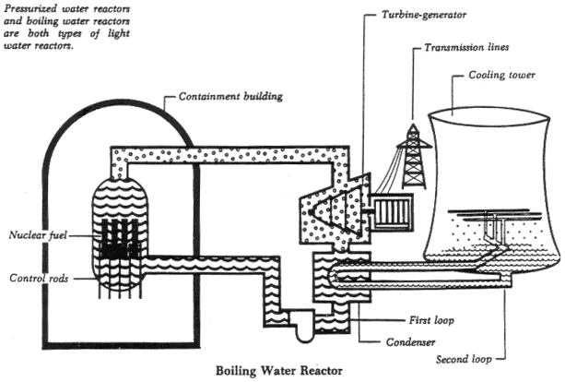

**Pressurized Heavy Water Reactor Power Plant:** In this case the water is pumped under high pressure to the reactor core which absorbs heat. The heated water from the reactor is sent to the heat exchanger, and the steam is generated in the secondary loop due to heat transfer from the hot water.

A pressurizer is attached to the primary loop, which is filled with water, steam bubbles are maintained above the water by heating it with a heater. This is done to maintain high pressure in the reactor. For decreasing the pressure a spray of high pressure water is sprayed to condensed steam.

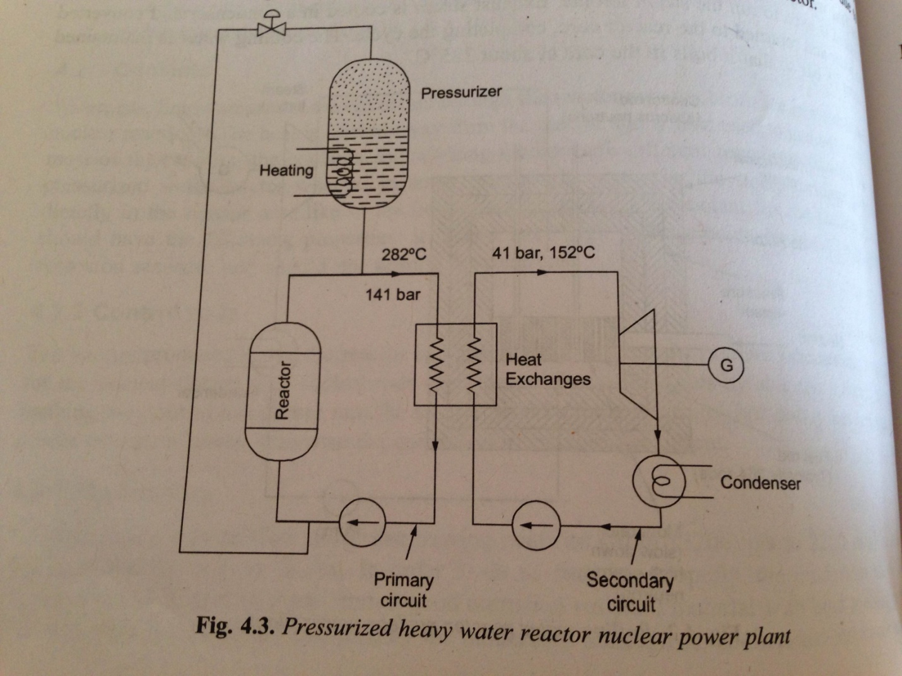

**Liquid Metal Cooled Reactor:** Molten metal like Sodium, Mercury or lead are used in the primary circuit of the reactor as coolant. Inspection and repair of the reactor is difficult because of opaque nature of molten metal. However the heat density of the coolant is quiet high.

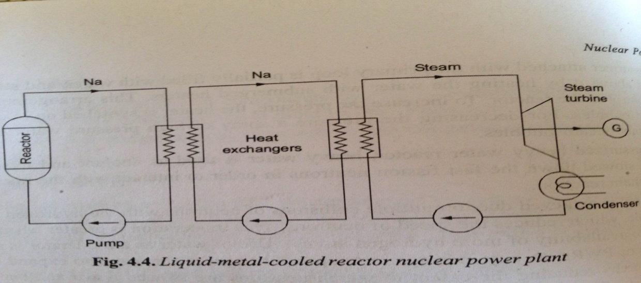

**Gas Cooled Reactor:** Inert gases like He,CO2or N2 can be used as coolant and circulated in the primary circuit. A heat exchanger is used to generate the steam. The fuel used in the gas cooled reactor is Plutonium and Thorium.

